Write a C# program in VS 2019 to compute the **Area** and **Perimeter** of a **Rectangle** with length and width entered by the user. Provide two text boxes for these inputs. Also provide two buttons as shown below. Make sure to format your output with 3 decimal places for Length and Width and 5 decimal places for Area.

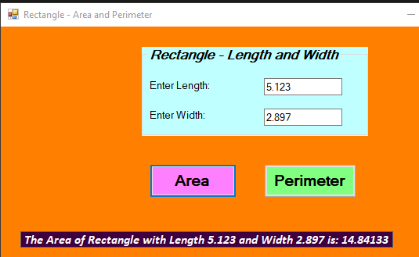**Area** of Rectangle = length * width

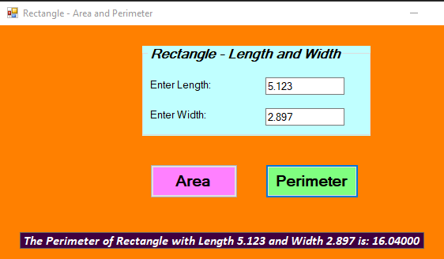

**Perimeter** of Rectangle = 2*(length + width)