**Decimal, the Base 10 Numbering System -** The decimal, denary or base 10 numbering system is what we use in everyday life for counting. The fact that there are ten symbols is more than likely because we have 10 fingers.

We use ten different symbols or *numerals* to represent the numbers from zero to nine.

Those numerals are 0, 1, 2, 3, 4, 5, 6, 7, 8 and 9

When we get to the number ten, we have no numeral to represent this value, so it is written as:

10

The idea is to use a new place holder for each power of 10 to make up any number we want.

So 134 means one hundred, 3 tens and a 4 although we just interpret and read it as one hundred and thirty four.

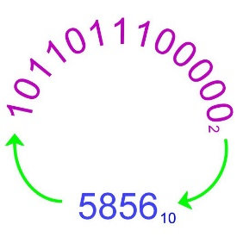

*Binary number and its decimal equivalent.* | Source

**Placeholder Value in the Decimal Numbering System**

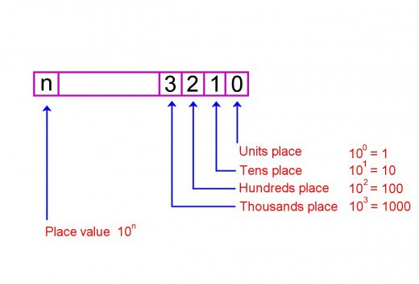

**Binary, the Base 2 Numbering System -** In the decimal number system, we saw that ten numerals were used to represent numbers from zero to nine.

Binary only uses two numerals 0 and 1. Place holders in binary each have a value of powers of 2. So the first place has a value 20 = 1, the second place 21 = 2, the third place 22 = 4, the fourth place 23 = 8 and so on.

In binary we count 0, 1 and then since there's no numeral for two we move onto the next place holder so two is written as 10 binary. This is exactly the same as when we get to ten decimal and have to write it as 10 because there's no numeral for ten.

**Placeholder Value in the Binary Numbering System**

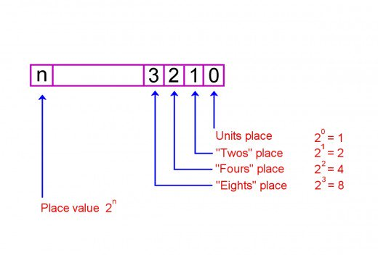

**Most Significant Bit (MSB) and Least Significant Bit (LSB)**

For a binary number, the *most significant bit* (MSB) is the digit furthermost to the left of the number and the *least significant bit*(LSB) is the rightmost digit.

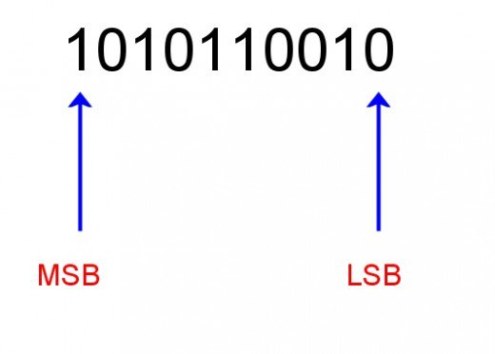

**Decimal and Binary Equivalents**

| **Decimal** | **Binary** |
| --- | --- |
| 0 | 0 |
| 1 | 1 |
| 2 | 10 |
| 3 | 11 |
| 4 | 100 |
| 5 | 101 |
| 6 | 110 |
| 7 | 111 |
| 8 | 1000 |

**Steps to Convert Decimal to Binary -** If you don't have a calculator to hand, you can easily convert a decimal number to binary using the remainder method. This involves dividing the number by 2 recursively until you're left with 0, while taking note of each remainder.

1. Write down the decimal number.
2. Divide the number by 2.
3. Write the result underneath.
4. Write the remainder on the right hand side. This will be 0 or 1.
5. Divide the result of the division by 2 and again write down the remainder.
6. Continue dividing and writing down remainders until the result of the division is 0.
7. The most significant bit (MSB) is at the bottom of the column of remainders and the least significant bit (LSB) is at the top.
8. Read the series of 1s and 0s on the right from the bottom up. This is the binary equivalent of the decimal number.

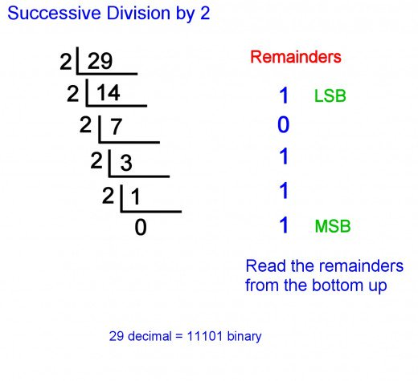

**Steps to Convert Binary to Decimal -** Converting from binary to decimal involves multiplying the value of each digit (i.e. 1 or 0) by the value of the placeholder in the number

1. Write down the number.
2. Starting with the LSB, multiply the digit by the value of the place holder.
3. Continue doing this until you reach the MSB.
4. Add the results together.

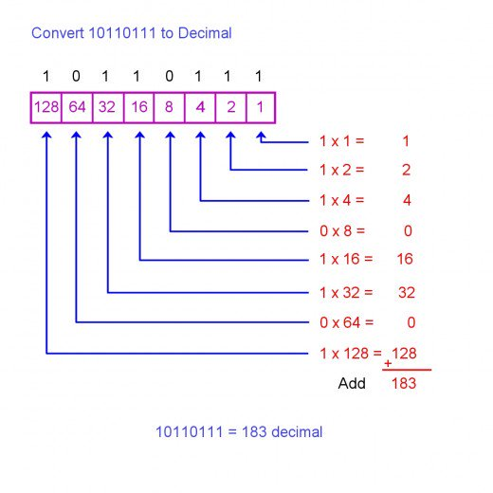

**Indicating the Base of a Number -** The binary number 1011011 can be written as 10110112 to explicitly indicate the base. Similarly 54 base 10 can be written 5410 Often however, the subscript is omitted to avoid excessive detail when the context is known. Usually subscripts are only included in explanatory text or notes in code to avoid confusion if several numbers with different bases are used together.

**What Other Bases Are There Apart From 2 and 10? -** Base 16 or hexadecimal (hex for short) is a shorthand used when programming computer systems. It uses sixteen symbols, representing 10, 11, 12, 13, 14 and 15 decimal with the letters A, B, C, D, E, and F respectively. You can read more about converting hex to binary and binary to hex here: