1. Select the cell(s) you want to create a rule for.
2. Select **Data >Data Validation**.

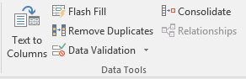

1. On the **Settings** tab, under **Allow**, select an option:
   * **Whole Number** - to restrict the cell to accept only whole numbers.
   * **Decimal** - to restrict the cell to accept only decimal numbers.
   * **List** - to pick data from the drop-down list.
   * **Date** - to restrict the cell to accept only date.
   * **Time** - to restrict the cell to accept only time.
   * **Text Length** - to restrict the length of the text.
   * **Custom** – for custom formula.
2. Under **Data**, select a condition.
3. Set the other required values based on what you chose for **Allow** and **Data**.
4. Select the **Input Message** tab and customize a message users will see when entering data.
5. Select the **Show input message when cell is selected** checkbox to display the message when the user selects or hovers over the selected cell(s).
6. Select the **Error Alert** tab to customize the error message and to choose a **Style**.
7. Select **OK**.