**Highlighting Duplicates Between Worksheets**

Let's say you have two Excel worksheets that have **overlapping data**and you want to **call attention to any cells that have duplicate entries**. You can do so using a **formula** and **conditional formatting**.

[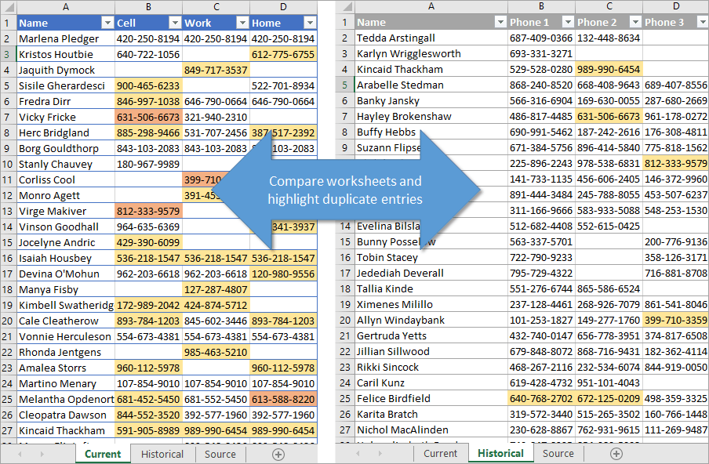](https://www.excelcampus.com/wp-content/uploads/2021/03/Compare-worksheets-and-highlight-duplicate-entries.png)

First let's look at how to **write the formula** and then we will see how to **apply the conditional formatting**.

**Use the COUNTIF Formula**

The formula we'll write is going to examine a cell to see if its **contents can be found in another range** that we specify. If so, it will return a value of the **number of times** that data is found. For this process we are using the **COUNTIF function**.

COUNTIF has **two arguments**. The first is **range** and the second is **criteria**. Range is the **group of cells that you want to look in**to find a specific value. In my video tutorial, my range is from B2 to F1001 on the “Historical” sheet.

The **criteria** argument is simply **the value that we are looking for**. In our example, that's cell B2.

If the value that is found in cell B2 is also found in our designated range on the Historical tab, the COUNTIF function will **return a number greater than zero**. If it is NOT found on that sheet, it will **return a zero**.

With conditional formatting, we use those numbers to highlight the entries that are duplicates.

For our example, the formula looks like this:

**=COUNTIF(Historical!$B$2:$F$1001,B2)**

It's important that the B2 used for the criteria argument is expressed as a **relative reference**, not an absolute reference. That's because when we apply the conditional formatting to our entire table, Excel will examine each cell individually to see if the criteria apply, but only if it's expressed as a relative reference (no dollar symbols in the reference).

COUNTIF formula


**Applying Conditional Formatting**

Now that we've looked at how the formula works, let's see how the **conditional formatting** is applied.

First select the entire **range of cells** that you want the formatting applied to. In our case it is all of the phone numbers on the “Current” worksheet. On the **Home** tab of the ribbon, choose the **Conditional Formatting drop-down menu** and select **New Rule**.

In the **New Formatting Rule** window, select the option that says **Use a formula to determine which cells to format**. That will open a field where you can write or paste the formula that we talked about above.

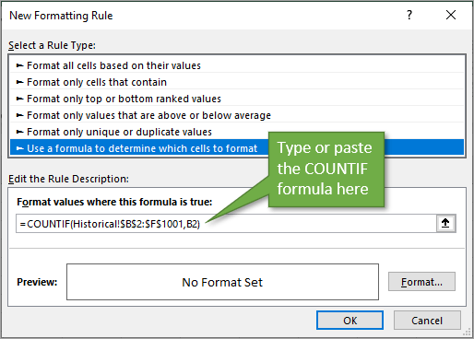

Next, select the **Format…** button and that will open the **Format Cells window**, where you can select any type of formatting you wish. Change the font, border, number type, or fill with color so that your **duplicates will stand out**. When you hit **OK**, and **OK** again, your formatting will be applied.

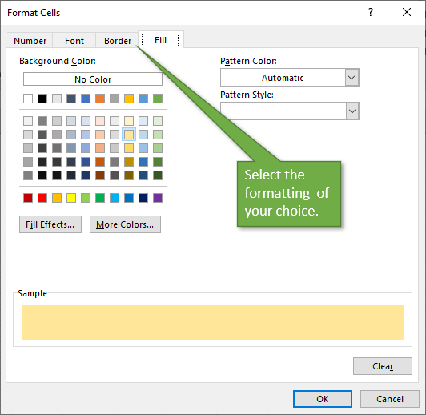

Any cell that returns a value larger than zero will have the **new formatting** applied.

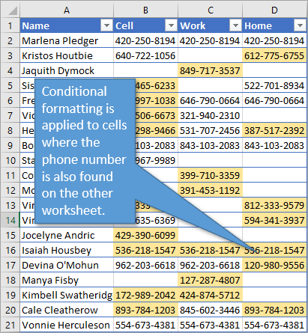

**Different Formatting for Multiple Duplicates**

If you'd like to highlight in a different color the entries that have **more than one duplicate** in the other sheet, you can simply add a new rule.

Start by reopening the Conditional Formatting Rules Manager (**Home** tab → **Conditional Formatting** → **Manage Rules**). We're going to select the rule we've already made and then hit **Duplicate Rule**. Once the rule is duplicated, select one of them and hit **Edit Rule**.

The only change we will make to the rule is to add “**>1**” to the end of the rule. Then we can select **Format** to choose a different color.

[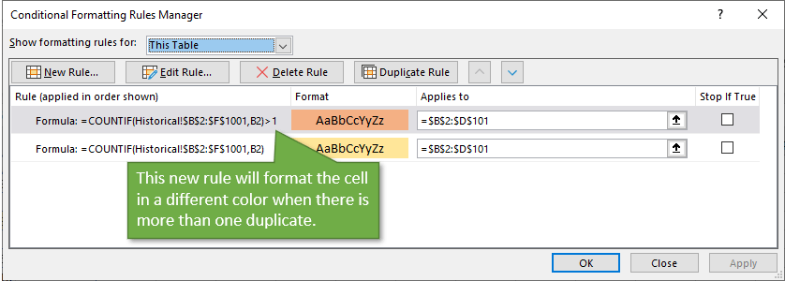](https://www.excelcampus.com/wp-content/uploads/2021/02/conditional-formatting-rules-manager-duplicate-entries.png)*Click to enlarge*

After hitting **Apply**, we see that our table now shows entries which have more than one duplicate in a different color:

